UNITED STATES
SECURITIES AND EXCHANGE COMMISSION
Washington, D.C. 20549
FORM 8-K
CURRENT REPORT
Pursuant to Section 13 or 15(d) of the
Securities Exchange Act of 1934
July 30, 2026
Date of Report (Date of earliest event reported)
AVERY DENNISON CORPORATION
(Exact name of registrant as specified in its charter)

Delaware |  |  |  |  |  | 1-7685 |  |  |  |  |  | 95-1492269
(State or other jurisdiction  of incorporation) |  |  |  |  |  | (Commission  File Number) |  |  |  |  |  | (IRS Employer  Identification No.)

8080 Norton Parkway
Mentor, Ohio |  |  |  |  |  | 44060
(Address of principal executive offices) |  |  |  |  |  | (Zip Code)
Registrant’s telephone number, including area code (440) 534-6000
(Former name or former address, if changed since last report.)
Check the appropriate box below if the Form 8-K filing is intended to simultaneously satisfy the filing obligation of the registrant under any of the following provisions (see General Instruction A.2. below):
☐ Written communications pursuant to Rule 425 under the Securities Act (17 CFR 230.425)
☐ Soliciting material pursuant to Rule 14a-12 under the Exchange Act (17 CFR 240.14a-12)
☐ Pre-commencement communications pursuant to Rule 14d-2(b) under the Exchange Act (17 CFR 240.14d-2(b))
☐ Pre-commencement communications pursuant to Rule 13e-4(c) under the Exchange Act (17 CFR 240.13e-4(c))
Securities registered pursuant to Section 12(b) of the Act:

Title of each class |  |  |  |  |  | Trading Symbol(s) |  |  |  |  |  | Name of each exchange on which registered
Common stock, $1 par value |  |  |  |  |  | AVY |  |  |  |  |  | New York Stock Exchange
3.750% Senior Notes due 2034 |  |  |  |  |  | AVY34 |  |  |  |  |  | Nasdaq Stock Market
4.000% Senior Notes due 2035 |  |  |  |  |  | AVY35 |  |  |  |  |  | Nasdaq Stock Market
Indicate by check mark whether the registrant is an emerging growth company as defined in Rule 405 of the Securities Act of 1933 (§230.405 of this chapter) or Rule 12b-2 of the Securities Exchange Act of 1934 (§240.12b-2 of this chapter).
Emerging growth company ☐
If an emerging growth company, indicate by check mark if the registrant has elected not to use the extended transition period for complying with any new or revised financial accounting standards provided pursuant to Section 13(a) of the Exchange Act. ☐

Section 2 — Corporate Governance and Management

Item 2.02 Results of Operations and Financial Condition.

Avery Dennison Corporation’s (the “Company’s”) press release, dated July 30, 2026, announcing its preliminary, unaudited financial results for second quarter 2026 and guidance for full-year 2026, is attached hereto as Exhibit 99.1 and being furnished (not filed) with this Form 8-K. The Company’s supplemental presentation materials, dated July 30, 2026, regarding its preliminary, unaudited financial review and analysis for second quarter 2026 and guidance for full-year 2026, is attached hereto as Exhibit 99.2 and being furnished (not filed) with this Form 8-K. The press release and presentation materials are also available on the Company's website at www.investors.averydennison.com.

The Company will discuss its preliminary, unaudited financial results during a webcast and teleconference to be held at 11:00 a.m. ET on July 30, 2026. To access the webcast and teleconference, please go to the Company’s website at www.investors.averydennison.com.

Section 9 — Financial Statements and Exhibits
Item 9.01 Financial Statements and Exhibits.
(d) Exhibits.

Exhibit  Number |  |  |  |  |  | Exhibit Title
99.1 |  |  |  |  |  | Press release, dated July 30, 2026, announcing the Company’s preliminary, unaudited financial results for second quarter 2026.
99.2 |  |  |  |  |  | Supplemental presentation materials, dated July 30, 2026, regarding the Company’s preliminary, unaudited financial review and analysis for second quarter 2026.
104 |  |  |  |  |  | Cover Page Interactive Data File (formatted in Inline XBRL and contained in Exhibit 101)

“Safe Harbor” Statement under the Private Securities Litigation Reform Act of 1995

Certain statements contained in this Form 8-K and the exhibits attached hereto are forward-looking statements intended to qualify for the safe harbor from liability established by the Private Securities Litigation Reform Act of 1995. These forward-looking statements, and financial or other business targets, are subject to certain risks and uncertainties.

The Company believes that the most significant risk factors that could affect its financial performance in the near term include: (i) the impact on underlying demand for the Company’s products from global economic conditions, tariffs, geopolitical uncertainty, and changes in environmental standards, regulations and preferences; (ii) competitors' actions, including pricing, expansion in key markets, and product offerings; (iii) the cost and availability of raw materials; (iv) the degree to which higher costs can be offset with productivity measures and/or passed on to customers through price increases, without a significant loss of volume; (v) foreign currency fluctuations; and (vi) the execution and integration of acquisitions.

Actual results and trends may differ materially from historical or anticipated results depending on a variety of factors, including but not limited to, risks and uncertainties related to the following:

•International Operations – worldwide economic, social, geopolitical and market conditions; changes in geopolitical conditions, including those related to trade relations and tariffs, China, recent conflicts involving the U.S., Israel and Iran and related hostilities in the Middle East, the Russia-Ukraine war, the Israel-Hamas war; fluctuations in foreign currency exchange rates; and other risks associated with international operations, including in emerging markets
•The Company’s Business – fluctuations in demand affecting sales to customers; fluctuations in the cost and availability of raw materials and energy; changes in the Company’s markets due to competitive conditions, technological developments, laws and regulations, and customer preferences; environmental regulations and sustainability trends; the impact of competitive products and pricing; the execution and integration of acquisitions; selling prices; customer and supplier concentrations or consolidations; the financial condition of distributors; outsourced manufacturers; product and service quality claims; restructuring and other cost reduction actions; our ability to generate sustained productivity improvement and our ability to achieve and

sustain targeted cost reductions; the timely development and market acceptance of new products, including sustainable or sustainably-sourced products; our investment in development activities and new production facilities; the collection of receivables from customers; and our sustainability and governance practices
•Information Technology – disruptions in information technology systems; cybersecurity events or other security breaches; and successful installation of new or upgraded information technology systems
•Income Taxes – fluctuations in tax rates; changes in tax laws and regulations, and uncertainties associated with interpretations of such laws and regulations; outcome of tax audits; and the realization of deferred tax assets
•Human Capital – recruitment and retention of employees and collective labor arrangements
•The Company’s Indebtedness – the Company’s ability to obtain adequate financing arrangements and maintain access to capital; credit rating risks; fluctuations in interest rates; and compliance with the Company’s debt covenants
•Ownership of the Company’s Stock – potential significant variability of the Company’s stock price and amounts of future dividends and share repurchases
•Legal and Regulatory Matters – protection and infringement of the Company’s intellectual property; the impact of legal and regulatory proceedings, including with respect to anti-corruption, environmental, health and safety, and trade compliance
•Other Financial Matters – fluctuations in pension costs and goodwill impairment

For a more detailed discussion of these factors, see Part I, Item 1A. “Risk Factors” and Part II, Item 7. “Management’s Discussion and Analysis of Financial Condition and Results of Operations” in the Company’s 2025 Form 10-K, filed with the Securities and Exchange Commission on February 25, 2026, and subsequent quarterly reports on Form 10-Q. The forward-looking statements included in this Form 8-K are made only as of the date of this Form 8-K, and the Company undertakes no obligation to update these statements to reflect subsequent events or circumstances, other than as may be required by law.

SIGNATURES
Pursuant to the requirements of the Securities Exchange Act of 1934, the registrant has duly caused this report to be signed on its behalf by the undersigned hereunto duly authorized.

 |  |  |  |  |  |  |  |  | AVERY DENNISON CORPORATION
Date: July 30, 2026 |  |  | By: |  |  |  |  |  | /s/ Gregory S. Lovins
 |  |  |  |  |  |  |  |  | Name: Gregory S. Lovins
 |  |  |  |  |  |  |  |  | Title: Senior Vice President and
 |  |  |  |  |  |  |  |  | Chief Financial Officer

Exhibit 99.1


For Immediate Release

AVERY DENNISON ANNOUNCES
SECOND QUARTER 2026 RESULTS
Delivered strong sales, earnings, and cash flow growth
●2Q26 Reported EPS of $2.67
○Adjusted EPS (non-GAAP) of $2.89, up 19.4%
●2Q26 Net sales of $2.5 billion, up 10.9%
○Sales change ex. currency (non-GAAP) up 8.9%
○Organic sales change (non-GAAP) up 7.6%
●FY26 Reported EPS guidance of $9.40 to $9.70
○FY26 Adjusted EPS guidance of $10.00 to $10.30

MENTOR, Ohio, July 30, 2026 – Avery Dennison Corporation (NYSE:AVY), a leading global materials science and digital identification solutions company, today announced preliminary, unaudited results for its second quarter ended June 30, 2026. Non-GAAP financial measures referenced in this release are reconciled from GAAP in the attached financial schedules. Unless otherwise indicated, comparisons are to the same period in the prior year.
“We delivered very strong second quarter results, marked by stronger-than-anticipated sales growth, solid margin expansion and adjusted EPS of $2.89, reflecting the strength of our portfolio and our team’s execution excellence,” said Deon Stander, president and CEO.
“Our focus on innovation and service-led differentiation continues to deliver for our customers, driving strong organic sales growth across both our high-value categories and base businesses. We continue to leverage our productivity playbook to expand margins and improve earnings growth while returning capital to shareholders.
“I am proud of our global team. Their agility and operational excellence continue to deliver strong performance, as we build on this momentum for the remainder of 2026 and beyond.”

Second Quarter 2026 Results by Segment
Materials Group
●Reported sales increased 15.9% to $1.8 billion.
●Sales were up 11.5% ex. currency.
●Sales up 9.7% on an organic basis
○Volume/mix growth of high single digits and price up low single digits
○High-value categories up mid-single digits
○Base categories up low double digits
●Reported operating margin of 15.6%
○Adjusted operating margin (non-GAAP) of 15.8%, up 20 basis points
○Adjusted EBITDA margin (non-GAAP) of 18.0%, up 20 basis points, as volume, productivity and the net benefit of pricing and raw material costs, including raw material re-engineering, were partially offset by mix and higher employee-related costs.
Solutions Group
●Reported sales decreased 0.5% to $667 million.
●Sales were up 2.6% ex. currency.
●Sales up 2.6% on an organic basis
○High-value categories up low single digits
○Base categories up low single digits
○Overall apparel categories up high single digits
●Reported operating margin of 8.9%
○Adjusted operating margin of 11.5%, up 150 basis points
○Adjusted EBITDA margin of 18.6%, up 150 basis points, as productivity was partially offset by higher employee-related costs.
Other
Capital Deployment and Balance Sheet
The company continues to deploy capital in a disciplined manner, executing its long-term capital allocation strategy.
During the first half of 2026, the company returned $347 million in cash to shareholders through a combination of share repurchases and dividends. The company repurchased 1.2 million shares, with payments for share purchases totaling $198 million. Net of dilution from long-term incentive awards, the company’s share count at the end of the second quarter was down 2.1 million compared to the same time last year.

The company’s balance sheet remains strong. Net debt to adjusted EBITDA (non-GAAP) was 2.3x at the end of the second quarter.
Income Taxes
The company’s reported effective tax rate was 27.8% and 28.8% for the three and six months ended June 30, 2026, respectively. The adjusted tax rate (non-GAAP) was 27.4% and 26.8% for the three and six months ended June 30, 2026, respectively.
Cost Reduction Actions
In the first half of the year, the company realized approximately $34 million in pre-tax savings from restructuring actions and incurred approximately $34 million in pre-tax restructuring charges.
Guidance
In its supplemental presentation materials, “Second Quarter 2026 Financial Review and Analysis,” the company provides a list of factors that it believes will contribute to its financial results. Based on the factors listed and other assumptions, the company expects full year 2026 reported EPS of $9.40 to $9.70.
Excluding an estimated $0.60 per share impact of other items and restructuring charges, the company expects full year 2026 adjusted EPS of $10.00 to $10.30.
For more details on the company’s results, see the summary tables accompanying this news release, as well as the supplemental presentation materials, “Second Quarter 2026 Financial Review and Analysis,” posted on the company’s website at www.investors.averydennison.com, and furnished to the SEC on Form 8-K.
Throughout this release and the supplemental presentation materials, amounts on a per share basis reflect fully diluted shares outstanding.

About Avery Dennison
Avery Dennison Corporation (NYSE: AVY) is a global materials science and digital identification solutions company. We are Making Possible™ products and solutions that help advance the industries we serve, providing branding and information solutions that optimize labor and supply chain efficiency, reduce waste and mitigate loss, advance sustainability, circularity and transparency and better connect brands and consumers. We design and develop labeling and functional materials, radio-frequency identification (RFID) inlays and tags, software applications that connect the physical and digital and offerings that enhance branded packaging and carry or display information that improves the customer experience. Serving industries worldwide — including home and personal care, apparel, general retail, e-commerce, logistics, food and grocery, pharmaceuticals and automotive — we employ approximately 35,000 employees in more than 50 countries. Our reported sales in 2025 were $8.9 billion. Learn more at www.averydennison.com.
# # #

“Safe Harbor” Statement under the Private Securities Litigation Reform Act of 1995
Certain statements contained in this document are "forward-looking statements" intended to qualify for the safe harbor from liability established by the Private Securities Litigation Reform Act of 1995. These forward-looking statements, and financial or other business targets, are subject to certain risks and uncertainties.

We believe that the most significant risk factors that could affect our financial performance in the near term include: (i) the impact on underlying demand for our products from global economic conditions, tariffs, geopolitical uncertainty, and changes in environmental standards, regulations and preferences; (ii) competitors’ actions, including pricing, expansion in key markets, and product offerings; (iii) the cost and availability of raw materials; (iv) the degree to which higher costs can be offset with productivity measures and/or passed on to customers through price increases, without a significant loss of volume; (v) foreign currency fluctuations; and (vi) the execution and integration of acquisitions.

Actual results and trends may differ materially from historical or anticipated results depending on a variety of factors, including but not limited to, risks and uncertainties related to the following:

●International Operations – worldwide economic, social, geopolitical and market conditions; changes in geopolitical conditions, including those related to trade relations and tariffs, China, recent conflicts involving the U.S., Israel and Iran and related hostilities in the Middle East, the Russia-Ukraine war, the Israel-Hamas war; fluctuations in foreign currency exchange rates; and other risks associated with international operations, including in emerging markets
●Our Business – fluctuations in demand affecting sales to customers; fluctuations in the cost and availability of raw materials and energy; changes in our markets due to competitive conditions, technological developments, laws and regulations, and customer preferences; environmental regulations and sustainability trends; the impact of competitive products and pricing; the execution and integration of acquisitions; selling prices; customer and supplier concentrations or consolidations; the financial condition of distributors; outsourced manufacturers; product and service quality claims; restructuring and other cost reduction actions; our ability to generate sustained productivity improvement and our ability to achieve and sustain targeted cost reductions; the timely development and market acceptance of new products, including sustainable or sustainably-sourced products; our investment in development activities and new production facilities; the collection of receivables from customers; and our sustainability and governance practices
●Information Technology – disruptions in information technology systems; cybersecurity events or other security breaches; and successful installation of new or upgraded information technology systems
●Income Taxes – fluctuations in tax rates; changes in tax laws and regulations, and uncertainties associated with interpretations of such laws and regulations; outcome of tax audits; and the realization of deferred tax assets
●Human Capital – recruitment and retention of employees and collective labor arrangements
●Our Indebtedness – our ability to obtain adequate financing arrangements and maintain access to capital; credit rating risks; fluctuations in interest rates; and compliance with our debt covenants
●Ownership of Our Stock – potential significant variability of our stock price and amounts of future dividends and share repurchases
●Legal and Regulatory Matters – protection and infringement of our intellectual property; the impact of legal and regulatory proceedings, including with respect to anti-corruption, environmental, health and safety, and trade compliance
●Other Financial Matters – fluctuations in pension costs and goodwill impairment

For a more detailed discussion of these factors, see “Risk Factors” and “Management’s Discussion and Analysis of Financial Condition and Results of Operations” in our 2025 Form 10-K, filed with the Securities and Exchange Commission on February 25, 2026, and subsequent quarterly reports on Form 10-Q.

The forward-looking statements included in this document are made only as of the date of this document, and we undertake no obligation to update these statements to reflect subsequent events or circumstances, other than as may be required by law.
For more information and to listen to a live broadcast or an audio replay of the quarterly conference call with analysts, visit the Avery Dennison website at www.investors.averydennison.com.

Contacts:
William Gilchrist
Vice President, Investor Relations
investorcom@averydennison.com

Kristin Robinson
Vice President, Global Communications
kristin.robinson@averydennison.com

 |  |  | Second Quarter Financial Summary - Preliminary, unaudited
 |  |  | (in millions, except % and per share amounts)
 |  |  |  |  |  | 2Q |  |  | 2Q |  |  | % Net Sales Change vs. PY
 |  |  |  |  |  | 2026 |  |  | 2025 |  |  | GAAP |  |  | Ex. Currency |  |  | Organic
 |  |  |  |  |  |  |  |  |  |  |  |  |  |  | (non-GAAP) |  |  | (non-GAAP)
 |  |  | Net sales, by segment:
 |  |  | Materials Group |  |  | $ | 1,796.1 |  | $ | 1,550.2 |  | 15.9% |  |  | 11.5% |  |  | 9.7%
 |  |  | Solutions Group |  |  | 666.8 |  |  | 670.3 |  |  | (0.5)% |  |  | 2.6% |  |  | 2.6%
 |  |  | Total net sales |  |  | $ | 2,462.9 |  | $ | 2,220.5 |  | 10.9% |  |  | 8.9% |  |  | 7.6%
 |  |  |  |  |  |  |  |  |  |  |  |  |  |  | % of Net Sales
 |  |  |  |  |  | 2Q |  |  | 2Q |  |  | % |  |  | 2Q |  |  | 2Q
 |  |  |  |  |  | 2026 |  |  | 2025 |  |  | Change |  |  | 2026 |  |  | 2025
 |  |  | Segment adjusted operating income and margins:
 |  |  | Materials Group |  |  | $ | 284.0 |  | $ | 242.5 |  |  |  |  | 15.8% |  |  | 15.6%
 |  |  | Solutions Group |  |  | 76.5 |  |  | 67.0 |  |  |  |  |  | 11.5% |  |  | 10.0%
 |  |  | Corporate expense |  |  | (25.9) |  |  | (22.8)
 |  |  | Adjusted operating income and margins (non-GAAP) |  |  | $ | 334.6 |  | $ | 286.7 |  | 16.7% |  |  | 13.6% |  |  | 12.9%
 |  |  | Segment adjusted EBITDA and margins:
 |  |  | Materials Group |  |  | $ | 322.6 |  | $ | 275.5 |  |  |  |  | 18.0% |  |  | 17.8%
 |  |  | Solutions Group |  |  | 124.3 |  |  | 114.8 |  |  |  |  |  | 18.6% |  |  | 17.1%
 |  |  | Corporate expense |  |  | (25.9) |  |  | (22.8)
 |  |  | Adjusted EBITDA and margins (non-GAAP) |  |  | $ | 421.0 |  | $ | 367.5 |  | 14.6% |  |  | 17.1% |  |  | 16.6%
 |  |  | Net income |  |  | $ | 204.1 |  | $ | 189.0 |  | 8.0% |  |  | 8.3% |  |  | 8.5%
 |  |  | Adjusted net income (non-GAAP) |  |  | $ | 220.5 |  | $ | 189.5 |  | 16.4% |  |  | 9.0% |  |  | 8.5%
 |  |  | Net income per common share, assuming dilution |  |  | $ | 2.67 |  | $ | 2.41 |  | 10.8%
 |  |  | Adjusted net income per common share, assuming dilution (non-GAAP) |  |  | $ | 2.89 |  | $ | 2.42 |  | 19.4%
 |  |  | Adjusted free cash flow (non-GAAP) |  |  | $ | 365.4 |  | $ | 188.9
 |  |  | YTD Adjusted free cash flow |  |  | $ | 469.8 |  | $ | 135.8
 |  |  | See accompanying schedules A-4 to A-8 for reconciliations of non-GAAP financial measures from GAAP.

A-1

AVERY DENNISON CORPORATION
PRELIMINARY CONDENSED CONSOLIDATED STATEMENTS OF INCOME
(In millions, except per share amounts)

 |  |  | (UNAUDITED)
 |  |  | Three Months Ended |  |  |  |  |  |  |  |  |  |  |  | Six Months Ended
 |  |  | Jun. 30, 2026 |  |  |  |  |  | Jun. 28, 2025 |  |  |  |  |  | Jun. 30, 2026 |  |  |  |  |  | Jun. 28, 2025
Net sales |  |  | $ | 2,462.9 |  |  |  |  | $ | 2,220.5 |  |  |  |  | $ | 4,761.4 |  |  |  |  | $ | 4,368.8
Cost of products sold |  |  | 1,733.5 |  |  |  |  |  | 1,581.4 |  |  |  |  |  | 3,367.2 |  |  |  |  |  | 3,108.2
Gross profit |  |  | 729.4 |  |  |  |  |  | 639.1 |  |  |  |  |  | 1,394.2 |  |  |  |  |  | 1,260.6
Marketing, general and administrative expense |  |  | 394.8 |  |  |  |  |  | 352.4 |  |  |  |  |  | 769.9 |  |  |  |  |  | 699.4
Other expense (income), net |  |  | 21.1 |  |  |  |  |  | 0.5 |  |  |  |  |  | 38.9 |  |  |  |  |  | 20.4
Interest expense |  |  | 35.9 |  |  |  |  |  | 34.0 |  |  |  |  |  | 71.5 |  |  |  |  |  | 64.9
Other non-operating expense (income), net |  |  | (5.1) |  |  |  |  |  | (3.3) |  |  |  |  |  | (9.2) |  |  |  |  |  | (6.6)
Income before taxes |  |  | 282.7 |  |  |  |  |  | 255.5 |  |  |  |  |  | 523.1 |  |  |  |  |  | 482.5
Provision for income taxes |  |  | 78.6 |  |  |  |  |  | 66.5 |  |  |  |  |  | 150.9 |  |  |  |  |  | 127.2
Net income |  |  | $ | 204.1 |  |  |  |  | $ | 189.0 |  |  |  |  | $ | 372.2 |  |  |  |  | $ | 355.3
Per share amounts:
Net income per common share, assuming dilution |  |  | $ | 2.67 |  |  |  |  | $ | 2.41 |  |  |  |  | $ | 4.85 |  |  |  |  | $ | 4.50
Weighted average number of common shares  outstanding, assuming dilution |  |  | 76.4 |  |  |  |  |  | 78.3 |  |  |  |  |  | 76.7 |  |  |  |  |  | 78.9

A-2
-more-

AVERY DENNISON CORPORATION
PRELIMINARY CONDENSED CONSOLIDATED BALANCE SHEETS
(In millions)

 |  |  | (UNAUDITED)
ASSETS |  |  | Jun. 30, 2026 |  |  |  |  |  | Jun. 28, 2025
Current assets:
Cash and cash equivalents |  |  | $ | 227.3 |  |  |  |  | $ | 215.9
Trade accounts receivable, net |  |  | 1,793.5 |  |  |  |  |  | 1,626.5
Inventories |  |  | 1,031.7 |  |  |  |  |  | 1,026.9
Other current assets |  |  | 348.0 |  |  |  |  |  | 314.5
Total current assets |  |  | 3,400.5 |  |  |  |  |  | 3,183.8
Property, plant and equipment, net |  |  | 1,565.1 |  |  |  |  |  | 1,604.2
Goodwill and other intangibles resulting from business acquisitions, net |  |  | 3,038.2 |  |  |  |  |  | 2,744.6
Deferred tax assets |  |  | 139.8 |  |  |  |  |  | 131.6
Other assets |  |  | 1,068.7 |  |  |  |  |  | 904.0
Total assets |  |  | $ | 9,212.3 |  |  |  |  | $ | 8,568.2
LIABILITIES AND SHAREHOLDERS' EQUITY
Current liabilities:
Short-term borrowings and current portion of long-term debt and finance leases |  |  | $ | 500.5 |  |  |  |  | $ | 922.0
Accounts payable |  |  | 1,524.7 |  |  |  |  |  | 1,307.5
Other current liabilities |  |  | 979.8 |  |  |  |  |  | 832.6
Total current liabilities |  |  | 3,005.0 |  |  |  |  |  | 3,062.1
Long-term debt and finance leases |  |  | 3,177.7 |  |  |  |  |  | 2,628.2
Other long-term liabilities |  |  | 706.8 |  |  |  |  |  | 676.3
Shareholders' equity:
Common stock |  |  | 124.1 |  |  |  |  |  | 124.1
Capital in excess of par value |  |  | 822.1 |  |  |  |  |  | 821.9
Retained earnings |  |  | 5,844.0 |  |  |  |  |  | 5,399.3
Treasury stock at cost |  |  | (4,087.9) |  |  |  |  |  | (3,693.7)
Accumulated other comprehensive loss |  |  | (379.5) |  |  |  |  |  | (450.0)
Total shareholders' equity |  |  | 2,322.8 |  |  |  |  |  | 2,201.6
Total liabilities and shareholders' equity |  |  | $ | 9,212.3 |  |  |  |  | $ | 8,568.2

A-3
-more-

AVERY DENNISON CORPORATION
PRELIMINARY CONDENSED CONSOLIDATED STATEMENTS OF CASH FLOWS
(In millions)
 |  |  | (UNAUDITED)
 |  |  | Six Months Ended
 |  |  | Jun. 30, 2026 |  |  |  |  |  | Jun. 28, 2025
Operating Activities
Net income |  |  | $ | 372.2 |  |  |  |  | $ | 355.3
Adjustments to reconcile net income to net cash provided by operating activities:
Depreciation |  |  | 106.4 |  |  |  |  |  | 100.3
Amortization |  |  | 66.8 |  |  |  |  |  | 58.4
Provision for credit losses and sales returns |  |  | 27.2 |  |  |  |  |  | 25.3
Stock-based compensation |  |  | 12.2 |  |  |  |  |  | 14.7
Deferred taxes and other non-cash taxes |  |  | (19.2) |  |  |  |  |  | (12.0)
Other non-cash expense and loss (income and gain), net |  |  | 29.2 |  |  |  |  |  | 20.8
Changes in assets and liabilities and other adjustments |  |  | (50.1) |  |  |  |  |  | (370.3)
Net cash provided by operating activities |  |  | 544.7 |  |  |  |  |  | 192.5
Investing Activities
Purchases of property, plant and equipment |  |  | (67.5) |  |  |  |  |  | (66.0)
Purchases of software and other deferred charges |  |  | (13.9) |  |  |  |  |  | (15.2)
Proceeds from sales of property, plant and equipment |  |  | 0.7 |  |  |  |  |  | 15.7
Proceeds from insurance and sales (purchases) of investments, net |  |  | 5.8 |  |  |  |  |  | 8.8
Proceeds from settlement of net investment hedges |  |  | --- |  |  |  |  |  | 6.2
Payments for acquisitions, net of cash acquired, and venture investments |  |  | (75.5) |  |  |  |  |  | (10.7)
Net cash used in investing activities |  |  | (150.4) |  |  |  |  |  | (61.2)
Financing Activities
Net increase (decrease) in borrowings with maturities of three months or less |  |  | (9.6) |  |  |  |  |  | 816.2
Repayments of long-term debt and finance leases |  |  | (3.4) |  |  |  |  |  | (551.6)
Dividends paid |  |  | (148.5) |  |  |  |  |  | (142.9)
Share repurchases |  |  | (198.2) |  |  |  |  |  | (360.0)
Net (tax withholding) proceeds related to stock-based compensation |  |  | (9.4) |  |  |  |  |  | (12.6)
Payments for settlement of fair value hedges |  |  | --- |  |  |  |  |  | (13.5)
Other |  |  | (0.5) |  |  |  |  |  | 15.9
Net cash used in financing activities |  |  | (369.6) |  |  |  |  |  | (248.5)
Effect of foreign currency translation on cash balances |  |  | (0.2) |  |  |  |  |  | 4.0
Increase (decrease) in cash and cash equivalents |  |  | 24.5 |  |  |  |  |  | (113.2)
Cash and cash equivalents, beginning of year |  |  | 202.8 |  |  |  |  |  | 329.1
Cash and cash equivalents, end of period |  |  | $ | 227.3 |  |  |  |  | $ | 215.9

A-4
-more-

Reconciliation of Non-GAAP Financial Measures from GAAP
We report our financial results in conformity with accounting principles generally accepted in the United States of America, or GAAP, and also communicate with investors using certain non-GAAP financial measures. These non-GAAP financial measures are not in accordance with, nor are they a substitute for or superior to, the comparable GAAP financial measures. These non-GAAP financial measures are intended to supplement the presentation of our financial results prepared in accordance with GAAP. We use these non-GAAP financial measures internally to evaluate trends in our underlying performance, as well as to facilitate comparisons with the results of competitors for quarters and year-to-date periods, as applicable. Based on feedback from investors and financial analysts, we believe that the supplemental non-GAAP financial measures we provide are also useful to their assessments of our performance and operating trends, as well as liquidity. Reconciliations of our non-GAAP financial measures from the most directly comparable GAAP financial measures are provided in accordance with Regulations G and S-K.
Our non-GAAP financial measures exclude the impact of certain events, activities or strategic decisions. The accounting effects of these events, activities or decisions, which are included in the GAAP financial measures, may make it more difficult to assess our underlying performance in a single period. By excluding the accounting effects, positive or negative, of certain items (e.g., restructuring charges, outcomes of certain legal matters and settlements, certain effects of strategic transactions and related costs, losses from debt extinguishments, gains or losses from curtailment or settlement of pension obligations, gains or losses on sales of certain assets, gains or losses on venture and other investments, currency adjustments due to highly inflationary economies, and other items), we believe that we are providing meaningful supplemental information that facilitates an understanding of our core operating results and liquidity measures. While some of the items we exclude from GAAP financial measures recur, they tend to be disparate in amount, frequency or timing.
We use the non-GAAP financial measures described below in the accompanying news release.
Sales change ex. currency refers to the increase or decrease in net sales, excluding the estimated impact of foreign currency translation, and, where applicable, currency adjustments for transitional reporting of highly inflationary economies and the reclassification of sales between segments. Additionally, where applicable, sales change ex. currency is also adjusted for the estimated impact of extra days in our fiscal year and the calendar shift resulting from extra days in the prior fiscal year. The estimated impact of foreign currency translation is calculated on a constant currency basis, with prior-period results translated at current-period average exchange rates to exclude the effect of foreign currency fluctuations. Our 2025 fiscal year began on December 29, 2024 and ended on December 31, 2025; fiscal years 2026 and beyond are coincident with the calendar year, beginning on January 1 and ending on December 31.
Organic sales change refers to sales change ex. currency, excluding the estimated impact of acquisitions and product line divestitures.
We believe that sales change ex. currency and organic sales change assist investors in evaluating the sales change from the ongoing activities of our businesses and enhance their ability to evaluate our results from period to period.
Adjusted operating income refers to net income adjusted for taxes; other expense (income), net; interest expense; and other non-operating expense (income), net.
Adjusted EBITDA refers to adjusted operating income before depreciation and amortization.
Adjusted operating margin refers to adjusted operating income as a percentage of net sales.
Adjusted EBITDA margin refers to adjusted EBITDA as a percentage of net sales.
Adjusted tax rate refers to the projected full-year GAAP tax rate, adjusted to exclude certain unusual or infrequent events that are expected to significantly impact that rate, such as effects of certain discrete tax planning actions, impacts related to enactments of tax law changes, and other items.
Adjusted net income refers to income before taxes, tax-effected at the adjusted tax rate, and adjusted for tax-effected restructuring charges and other items.
Adjusted net income per common share, assuming dilution (adjusted EPS) refers to adjusted net income divided by the weighted average number of common shares outstanding, assuming dilution.
We believe that adjusted operating margin, adjusted EBITDA margin, adjusted net income, and adjusted EPS assist investors in understanding our core operating trends and comparing our results with those of our competitors.
Net debt to adjusted EBITDA ratio refers to total debt (including finance leases) less cash and cash equivalents, divided by adjusted EBITDA for the last twelve months. We believe that the net debt to adjusted EBITDA ratio assists investors in assessing our leverage position.
Adjusted free cash flow refers to cash flow provided by (used in) operating activities, less payments for property, plant and equipment, less payments for software and other deferred charges, plus proceeds from sales of property, plant and equipment, plus (minus) net proceeds from insurance and sales (purchases) of investments. Where applicable, adjusted free cash flow is also adjusted for certain acquisition-related transaction costs, proceeds from company-owned life insurance policies and net cash used for Argentine Blue Chip Swap securities. We believe that adjusted free cash flow assists investors by showing the amount of cash we have available for debt reductions, dividends, share repurchases and acquisitions.

A-5
-more-

AVERY DENNISON CORPORATION
PRELIMINARY RECONCILIATION OF NON-GAAP FINANCIAL MEASURES FROM GAAP
(In millions, except % and per share amounts)

 |  |  | (UNAUDITED)
 |  |  | Three Months Ended |  |  |  |  |  |  |  |  |  |  |  | Six Months Ended
 |  |  | Jun. 30, 2026 |  |  |  |  |  | Jun. 28, 2025 |  |  |  |  |  | Jun. 30, 2026 |  |  |  |  |  | Jun. 28, 2025
Reconciliation of adjusted operating and EBITDA margins from GAAP:
Net sales |  |  | $ | 2,462.9 |  |  |  |  | $ | 2,220.5 |  |  |  |  | $ | 4,761.4 |  |  |  |  | $ | 4,368.8
Income before taxes |  |  | $ | 282.7 |  |  |  |  | $ | 255.5 |  |  |  |  | $ | 523.1 |  |  |  |  | $ | 482.5
Income before taxes as a percentage of net sales |  |  | 11.5 |  | % |  |  |  | 11.5 |  | % |  |  |  | 11.0 |  | % |  |  |  | 11.0 |  | %
Adjustments:
Interest expense |  |  | $ | 35.9 |  |  |  |  | $ | 34.0 |  |  |  |  | $ | 71.5 |  |  |  |  | $ | 64.9
Other non-operating expense (income), net |  |  | (5.1) |  |  |  |  |  | (3.3) |  |  |  |  |  | (9.2) |  |  |  |  |  | (6.6)
Operating income before interest expense, other non-operating expense (income) and taxes |  |  | $ | 313.5 |  |  |  |  | $ | 286.2 |  |  |  |  | $ | 585.4 |  |  |  |  | $ | 540.8
Operating margins |  |  | 12.7 |  | % |  |  |  | 12.9 |  | % |  |  |  | 12.3 |  | % |  |  |  | 12.4 |  | %
Net income |  |  | $ | 204.1 |  |  |  |  | $ | 189.0 |  |  |  |  | $ | 372.2 |  |  |  |  | $ | 355.3
Adjustments:
Restructuring charges, net of reversals:
Severance and related costs, net of reversals |  |  | 16.2 |  |  |  |  |  | 7.9 |  |  |  |  |  | 30.7 |  |  |  |  |  | 12.6
Asset impairment and lease cancellation charges |  |  | 2.4 |  |  |  |  |  | 0.1 |  |  |  |  |  | 3.7 |  |  |  |  |  | 0.3
(Gain) loss on venture and other investments |  |  | 1.2 |  |  |  |  |  | 1.8 |  |  |  |  |  | 2.5 |  |  |  |  |  | 16.1
Loss from Argentine peso remeasurement |  |  | 0.8 |  |  |  |  |  | 1.8 |  |  |  |  |  | 1.3 |  |  |  |  |  | 2.5
(Gain) loss on sales of assets |  |  | --- |  |  |  |  |  | (11.1) |  |  |  |  |  | (0.1) |  |  |  |  |  | (11.1)
Outcomes of legal matters and settlements |  |  | 0.5 |  |  |  |  |  | --- |  |  |  |  |  | 0.7 |  |  |  |  |  | ---
Transaction and related costs |  |  | --- |  |  |  |  |  | --- |  |  |  |  |  | 0.1 |  |  |  |  |  | ---
Interest expense |  |  | 35.9 |  |  |  |  |  | 34.0 |  |  |  |  |  | 71.5 |  |  |  |  |  | 64.9
Other non-operating expense (income), net(1) |  |  | (5.1) |  |  |  |  |  | (3.3) |  |  |  |  |  | (9.2) |  |  |  |  |  | (6.6)
Provision for income taxes |  |  | 78.6 |  |  |  |  |  | 66.5 |  |  |  |  |  | 150.9 |  |  |  |  |  | 127.2
Adjusted operating income (non-GAAP) |  |  | $ | 334.6 |  |  |  |  | $ | 286.7 |  |  |  |  | $ | 624.3 |  |  |  |  | $ | 561.2
Adjusted operating margins (non-GAAP) |  |  | 13.6 |  | % |  |  |  | 12.9 |  | % |  |  |  | 13.1 |  | % |  |  |  | 12.8 |  | %
Depreciation and amortization |  |  | $ | 86.4 |  |  |  |  | $ | 80.8 |  |  |  |  | $ | 173.2 |  |  |  |  | $ | 158.7
Adjusted EBITDA (non-GAAP) |  |  | $ | 421.0 |  |  |  |  | $ | 367.5 |  |  |  |  | $ | 797.5 |  |  |  |  | $ | 719.9
Adjusted EBITDA margins (non-GAAP) |  |  | 17.1 |  | % |  |  |  | 16.6 |  | % |  |  |  | 16.7 |  | % |  |  |  | 16.5 |  | %
Reconciliation of adjusted net income from GAAP:
Net income |  |  | $ | 204.1 |  |  |  |  | $ | 189.0 |  |  |  |  | $ | 372.2 |  |  |  |  | $ | 355.3
Adjustments:
Restructuring charges and other items |  |  | 21.0 |  |  |  |  |  | 0.5 |  |  |  |  |  | 38.7 |  |  |  |  |  | 20.3
Tax effect on restructuring charges and other items |  |  | (5.3) |  |  |  |  |  | (2.5) |  |  |  |  |  | (9.2) |  |  |  |  |  | (7.5)
Impact of adjusted tax rate(2) |  |  | 0.7 |  |  |  |  |  | 2.5 |  |  |  |  |  | 9.3 |  |  |  |  |  | 4.0
Adjusted net income (non-GAAP) |  |  | $ | 220.5 |  |  |  |  | $ | 189.5 |  |  |  |  | $ | 411.0 |  |  |  |  | $ | 372.1
(1) Included immaterial amounts of Argentine interest income for periods presented.
(2) Included net tax expense of approximately $4.7 related to the impact of certain tax law changes in a foreign jurisdiction for the six months ended June 30, 2026.

A-5
-more-
(continued)
AVERY DENNISON CORPORATION
PRELIMINARY RECONCILIATION OF NON-GAAP FINANCIAL MEASURES FROM GAAP
(In millions, except % and per share amounts)

 |  |  | (UNAUDITED)
 |  |  | Three Months Ended |  |  |  |  |  |  |  |  |  |  |  | Six Months Ended
 |  |  | Jun. 30, 2026 |  |  |  |  |  | Jun. 28, 2025 |  |  |  |  |  | Jun. 30, 2026 |  |  |  |  |  | Jun. 28, 2025
Reconciliation of adjusted net income per common share from GAAP:
Net income per common share, assuming dilution |  |  | $ | 2.67 |  |  |  |  | $ | 2.41 |  |  |  |  | $ | 4.85 |  |  |  |  | $ | 4.50
Adjustments per common share:
Restructuring charges and other items |  |  | 0.28 |  |  |  |  |  | 0.01 |  |  |  |  |  | 0.51 |  |  |  |  |  | 0.26
Tax effect on restructuring charges and other items |  |  | (0.07) |  |  |  |  |  | (0.03) |  |  |  |  |  | (0.12) |  |  |  |  |  | (0.09)
Impact of adjusted tax rate |  |  | 0.01 |  |  |  |  |  | 0.03 |  |  |  |  |  | 0.12 |  |  |  |  |  | 0.05
Adjusted net income per common share, assuming dilution (non-GAAP) |  |  | $ | 2.89 |  |  |  |  | $ | 2.42 |  |  |  |  | $ | 5.36 |  |  |  |  | $ | 4.72
Weighted average number of common shares outstanding, assuming dilution |  |  | 76.4 |  |  |  |  |  | 78.3 |  |  |  |  |  | 76.7 |  |  |  |  |  | 78.9
Our adjusted tax rate was 27.4% and 26.8% for the three and six months ended June 30, 2026, respectively, and 26.0% for both the three and six months ended June 28, 2025.
 |  |  | (UNAUDITED)
 |  |  | Three Months Ended |  |  |  |  |  |  |  |  |  |  |  | Six Months Ended
 |  |  | Jun. 30, 2026 |  |  |  |  |  | Jun. 28, 2025 |  |  |  |  |  | Jun. 30, 2026 |  |  |  |  |  | Jun. 28, 2025
Reconciliation of adjusted free cash flow from GAAP:
Net cash provided by operating activities |  |  | $ | 408.2 |  |  |  |  | $ | 208.8 |  |  |  |  | $ | 544.7 |  |  |  |  | $ | 192.5
Purchases of property, plant and equipment |  |  | (39.2) |  |  |  |  |  | (30.0) |  |  |  |  |  | (67.5) |  |  |  |  |  | (66.0)
Purchases of software and other deferred charges |  |  | (6.2) |  |  |  |  |  | (7.6) |  |  |  |  |  | (13.9) |  |  |  |  |  | (15.2)
Proceeds from sales of property, plant and equipment |  |  | --- |  |  |  |  |  | 15.7 |  |  |  |  |  | 0.7 |  |  |  |  |  | 15.7
Proceeds from insurance and sales (purchases) of investments, net |  |  | 2.6 |  |  |  |  |  | 2.0 |  |  |  |  |  | 5.8 |  |  |  |  |  | 8.8
Adjusted free cash flow (non-GAAP) |  |  | $ | 365.4 |  |  |  |  | $ | 188.9 |  |  |  |  | $ | 469.8 |  |  |  |  | $ | 135.8

A-6
-more-
AVERY DENNISON CORPORATION
PRELIMINARY SUPPLEMENTARY INFORMATION
(In millions, except %)
(UNAUDITED)

 |  |  | NET SALES
 |  |  | Three Months Ended |  |  |  |  |  |  |  |  |  |  |  | Six Months Ended
 |  |  | Jun. 30, 2026 |  |  |  |  |  | Jun. 28, 2025 |  |  |  |  |  | Jun. 30, 2026 |  |  |  |  |  | Jun. 28, 2025
Materials Group |  |  | $ | 1,796.1 |  |  |  |  | $ | 1,550.2 |  |  |  |  | $ | 3,445.4 |  |  |  |  | $ | 3,030.3
Solutions Group |  |  | 666.8 |  |  |  |  |  | 670.3 |  |  |  |  |  | 1,316.0 |  |  |  |  |  | 1,338.5
Total net sales |  |  | $ | 2,462.9 |  |  |  |  | $ | 2,220.5 |  |  |  |  | $ | 4,761.4 |  |  |  |  | $ | 4,368.8
RECONCILIATION OF NON-GAAP SUPPLEMENTARY INFORMATION FROM GAAP
 |  |  | Three Months Ended |  |  |  |  |  |  |  |  |  |  |  | Six Months Ended
 |  |  | Jun. 30, 2026 |  |  |  |  |  | Jun. 28, 2025 |  |  |  |  |  | Jun. 30, 2026 |  |  |  |  |  | Jun. 28, 2025
Materials Group
Operating income |  |  | $ | 280.1 |  |  |  |  | $ | 249.5 |  |  |  |  | $ | 526.6 |  |  |  |  | $ | 475.4
Adjustments:
Restructuring charges, net of reversals:
Severance and related costs, net of reversals |  |  | 2.8 |  |  |  |  |  | 2.5 |  |  |  |  |  | 8.8 |  |  |  |  |  | 5.0
Asset impairment and lease cancellation charges |  |  | --- |  |  |  |  |  | --- |  |  |  |  |  | 0.6 |  |  |  |  |  | ---
Loss from Argentine peso remeasurement |  |  | 0.8 |  |  |  |  |  | 1.8 |  |  |  |  |  | 1.3 |  |  |  |  |  | 2.5
(Gain) loss on venture and other investments |  |  | 0.3 |  |  |  |  |  | (0.2) |  |  |  |  |  | 0.7 |  |  |  |  |  | 1.0
(Gain) loss on sales of assets |  |  | --- |  |  |  |  |  | (11.1) |  |  |  |  |  | (0.1) |  |  |  |  |  | (11.1)
Outcomes of legal matters and settlements |  |  | --- |  |  |  |  |  | --- |  |  |  |  |  | 0.2 |  |  |  |  |  | ---
Transaction and related costs |  |  | --- |  |  |  |  |  | --- |  |  |  |  |  | 0.1 |  |  |  |  |  | ---
Adjusted operating income (non-GAAP) |  |  | $ | 284.0 |  |  |  |  | $ | 242.5 |  |  |  |  | $ | 538.2 |  |  |  |  | $ | 472.8
Depreciation and amortization |  |  | 38.6 |  |  |  |  |  | 33.0 |  |  |  |  |  | 77.3 |  |  |  |  |  | 64.5
Adjusted EBITDA (non-GAAP) |  |  | $ | 322.6 |  |  |  |  | $ | 275.5 |  |  |  |  | $ | 615.5 |  |  |  |  | $ | 537.3
Operating margins |  |  | 15.6 |  | % |  |  |  | 16.1 |  | % |  |  |  | 15.3 |  | % |  |  |  | 15.7 |  | %
Adjusted operating margins (non-GAAP) |  |  | 15.8 |  | % |  |  |  | 15.6 |  | % |  |  |  | 15.6 |  | % |  |  |  | 15.6 |  | %
Adjusted EBITDA margins (non-GAAP) |  |  | 18.0 |  | % |  |  |  | 17.8 |  | % |  |  |  | 17.9 |  | % |  |  |  | 17.7 |  | %
Solutions Group
Operating income |  |  | $ | 59.3 |  |  |  |  | $ | 59.8 |  |  |  |  | $ | 107.9 |  |  |  |  | $ | 117.9
Adjustments:
Restructuring charges, net of reversals:
Severance and related costs, net of reversals |  |  | 13.4 |  |  |  |  |  | 5.1 |  |  |  |  |  | 21.7 |  |  |  |  |  | 6.9
Asset impairment and lease cancellation charges |  |  | 2.4 |  |  |  |  |  | 0.1 |  |  |  |  |  | 3.1 |  |  |  |  |  | 0.3
(Gain) loss on venture and other investments |  |  | 0.9 |  |  |  |  |  | 2.0 |  |  |  |  |  | 1.8 |  |  |  |  |  | 10.1
Outcomes of legal matters and settlements |  |  | 0.5 |  |  |  |  |  | --- |  |  |  |  |  | 0.5 |  |  |  |  |  | ---
Adjusted operating income (non-GAAP) |  |  | $ | 76.5 |  |  |  |  | $ | 67.0 |  |  |  |  | $ | 135.0 |  |  |  |  | $ | 135.2
Depreciation and amortization |  |  | 47.8 |  |  |  |  |  | 47.8 |  |  |  |  |  | 95.9 |  |  |  |  |  | 94.2
Adjusted EBITDA (non-GAAP) |  |  | $ | 124.3 |  |  |  |  | $ | 114.8 |  |  |  |  | $ | 230.9 |  |  |  |  | $ | 229.4
Operating margins |  |  | 8.9 |  | % |  |  |  | 8.9 |  | % |  |  |  | 8.2 |  | % |  |  |  | 8.8 |  | %
Adjusted operating margins (non-GAAP) |  |  | 11.5 |  | % |  |  |  | 10.0 |  | % |  |  |  | 10.3 |  | % |  |  |  | 10.1 |  | %
Adjusted EBITDA margins (non-GAAP) |  |  | 18.6 |  | % |  |  |  | 17.1 |  | % |  |  |  | 17.5 |  | % |  |  |  | 17.1 |  | %

A-7
-more-
AVERY DENNISON CORPORATION
PRELIMINARY SUPPLEMENTARY INFORMATION
(In millions, except ratios)
(UNAUDITED)

 |  |  | QTD
 |  |  | 3Q25 |  |  | 4Q25 |  |  | 1Q26 |  |  | 2Q26
Reconciliation of adjusted EBITDA from GAAP:
Net income |  |  | $ | 166.3 |  | $ | 166.4 |  | $ | 168.1 |  | $ | 204.1
Other expense (income), net |  |  | 16.7 |  |  | 40.4 |  |  | 17.8 |  |  | 21.1
Interest expense |  |  | 33.3 |  |  | 37.2 |  |  | 35.6 |  |  | 35.9
Other non-operating expense (income), net |  |  | (3.7) |  |  | (3.9) |  |  | (4.1) |  |  | (5.1)
Provision for income taxes |  |  | 68.5 |  |  | 41.4 |  |  | 72.3 |  |  | 78.6
Depreciation and amortization |  |  | 84.0 |  |  | 85.5 |  |  | 86.8 |  |  | 86.4
Adjusted EBITDA (non-GAAP) |  |  | $ | 365.1 |  | $ | 367.0 |  | $ | 376.5 |  | $ | 421.0
Total Debt |  |  |  |  |  |  |  |  |  |  |  | $ | 3,678.2
Less: Cash and cash equivalents |  |  |  |  |  |  |  |  |  |  |  | 227.3
Net Debt |  |  |  |  |  |  |  |  |  |  |  | $ | 3,450.9
Net Debt to Adjusted EBITDA LTM* (non-GAAP) |  |  |  |  |  |  |  |  |  |  |  | 2.3
*LTM = Last twelve months (3Q25 through 2Q26)

A-8
-more-
AVERY DENNISON CORPORATION
PRELIMINARY SUPPLEMENTARY INFORMATION
(UNAUDITED)

 |  |  | Three Months Ended
 |  |  | Jun. 30, 2026
 |  |  | Total  Company |  |  | Materials  Group |  |  | Solutions  Group
Reconciliation of organic sales change from GAAP:
Net sales change |  |  | 10.9% |  |  | 15.9% |  |  | (0.5)%
Reclassification of sales between segments |  |  | --- |  |  | (1.7)% |  |  | 3.8%
Foreign currency translation |  |  | (2.0)% |  |  | (2.6)% |  |  | (0.6)%
Sales change ex. currency (non-GAAP)(1) |  |  | 8.9% |  |  | 11.5% |  |  | 2.6%
Acquisitions |  |  | (1.3)% |  |  | (1.8)% |  |  | ---
Organic sales change (non-GAAP)(1) |  |  | 7.6% |  |  | 9.7% |  |  | 2.6%
(1) Totals may not sum due to rounding.
 |  |  | Six Months Ended
 |  |  | Jun. 30, 2026
 |  |  | Total  Company |  |  | Materials  Group |  |  | Solutions  Group
Reconciliation of organic sales change from GAAP:
Net sales change |  |  | 9.0% |  |  | 13.7% |  |  | (1.7)%
Reclassification of sales between segments |  |  | --- |  |  | (1.6)% |  |  | 3.4%
Foreign currency translation |  |  | (3.4)% |  |  | (4.6)% |  |  | (0.9)%
Sales change ex. currency (non-GAAP)(1) |  |  | 5.6% |  |  | 7.6% |  |  | 0.9%
Acquisitions |  |  | (1.2)% |  |  | (1.7)% |  |  | ---
Organic sales change (non-GAAP)(1) |  |  | 4.4% |  |  | 5.8% |  |  | 0.9%
(1) Totals may not sum due to rounding.
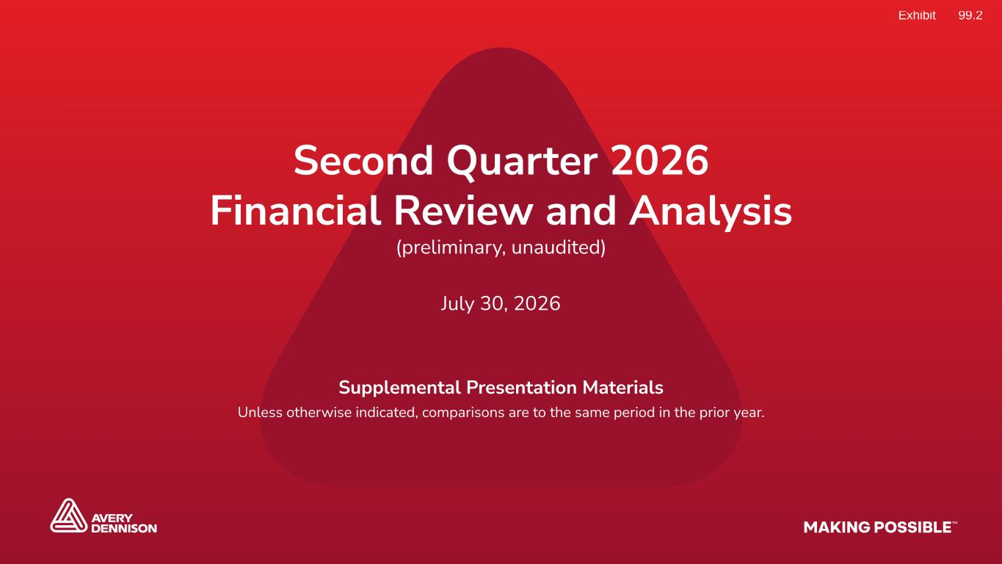

1July 30, 2026 Preliminary & unaudited, Q2 2026 financial review and analysis Classification: Avery Dennison - Secret Second Quarter 2026 Financial Review and Analysis (preliminary, unaudited) July 30, 2026 Supplemental Presentation Materials Unless otherwise indicated, comparisons are to the same period in the prior year.

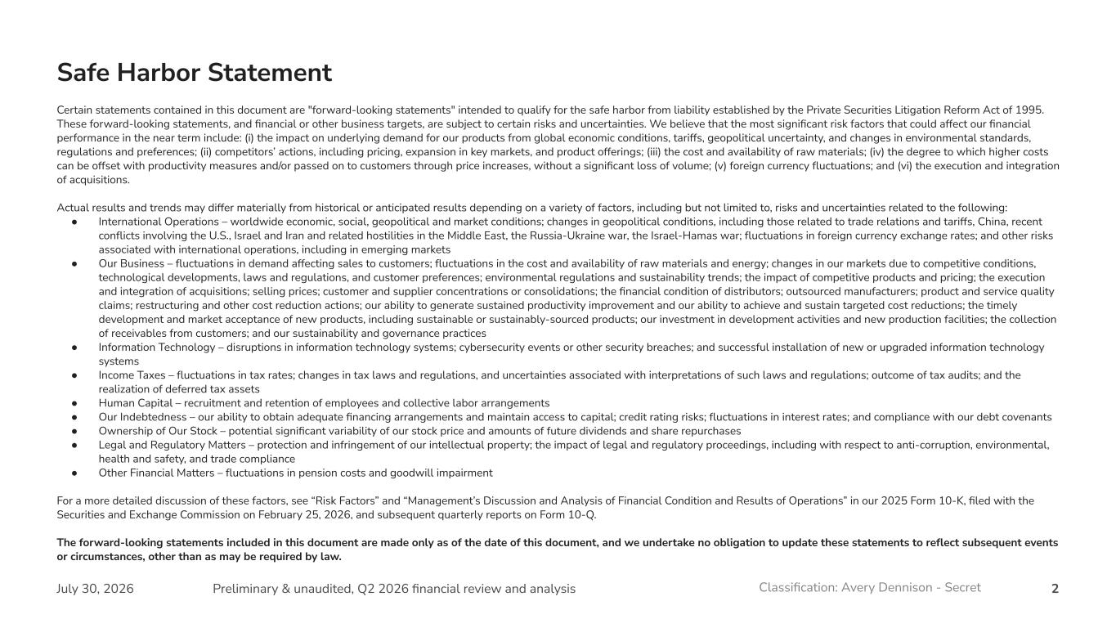
2July 30, 2026 Preliminary & unaudited, Q2 2026 financial review and analysis Classification: Avery Dennison - Secret Certain statements contained in this document are "forward-looking statements" intended to qualify for the safe harbor from liability established by the Private Securities Litigation Reform Act of 1995. These forward-looking statements, and financial or other business targets, are subject to certain risks and uncertainties. We believe that the most significant risk factors that could affect our financial performance in the near term include: (i) the impact on underlying demand for our products from global economic conditions, tariffs, geopolitical uncertainty, and changes in environmental standards, regulations and preferences; (ii) competitors’ actions, including pricing, expansion in key markets, and product offerings; (iii) the cost and availability of raw materials; (iv) the degree to which higher costs can be offset with productivity measures and/or passed on to customers through price increases, without a significant loss of volume; (v) foreign currency fluctuations; and (vi) the execution and integration of acquisitions. Actual results and trends may differ materially from historical or anticipated results depending on a variety of factors, including but not limited to, risks and uncertainties related to the following: ● International Operations – worldwide economic, social, geopolitical and market conditions; changes in geopolitical conditions, including those related to trade relations and tariffs, China, recent conflicts involving the U.S., Israel and Iran and related hostilities in the Middle East, the Russia-Ukraine war, the Israel-Hamas war; fluctuations in foreign currency exchange rates; and other risks associated with international operations, including in emerging markets ● Our Business – fluctuations in demand affecting sales to customers; fluctuations in the cost and availability of raw materials and energy; changes in our markets due to competitive conditions, technological developments, laws and regulations, and customer preferences; environmental regulations and sustainability trends; the impact of competitive products and pricing; the execution and integration of acquisitions; selling prices; customer and supplier concentrations or consolidations; the financial condition of distributors; outsourced manufacturers; product and service quality claims; restructuring and other cost reduction actions; our ability to generate sustained productivity improvement and our ability to achieve and sustain targeted cost reductions; the timely development and market acceptance of new products, including sustainable or sustainably-sourced products; our investment in development activities and new production facilities; the collection of receivables from customers; and our sustainability and governance practices ● Information Technology – disruptions in information technology systems; cybersecurity events or other security breaches; and successful installation of new or upgraded information technology systems ● Income Taxes – fluctuations in tax rates; changes in tax laws and regulations, and uncertainties associated with interpretations of such laws and regulations; outcome of tax audits; and the realization of deferred tax assets ● Human Capital – recruitment and retention of employees and collective labor arrangements ● Our Indebtedness – our ability to obtain adequate financing arrangements and maintain access to capital; credit rating risks; fluctuations in interest rates; and compliance with our debt covenants ● Ownership of Our Stock – potential significant variability of our stock price and amounts of future dividends and share repurchases ● Legal and Regulatory Matters – protection and infringement of our intellectual property; the impact of legal and regulatory proceedings, including with respect to anti-corruption, environmental, health and safety, and trade compliance ● Other Financial Matters – fluctuations in pension costs and goodwill impairment For a more detailed discussion of these factors, see “Risk Factors” and “Management’s Discussion and Analysis of Financial Condition and Results of Operations” in our 2025 Form 10-K, filed with the Securities and Exchange Commission on February 25, 2026, and subsequent quarterly reports on Form 10-Q. The forward-looking statements included in this document are made only as of the date of this document, and we undertake no obligation to update these statements to reflect subsequent events or circumstances, other than as may be required by law. Safe Harbor Statement

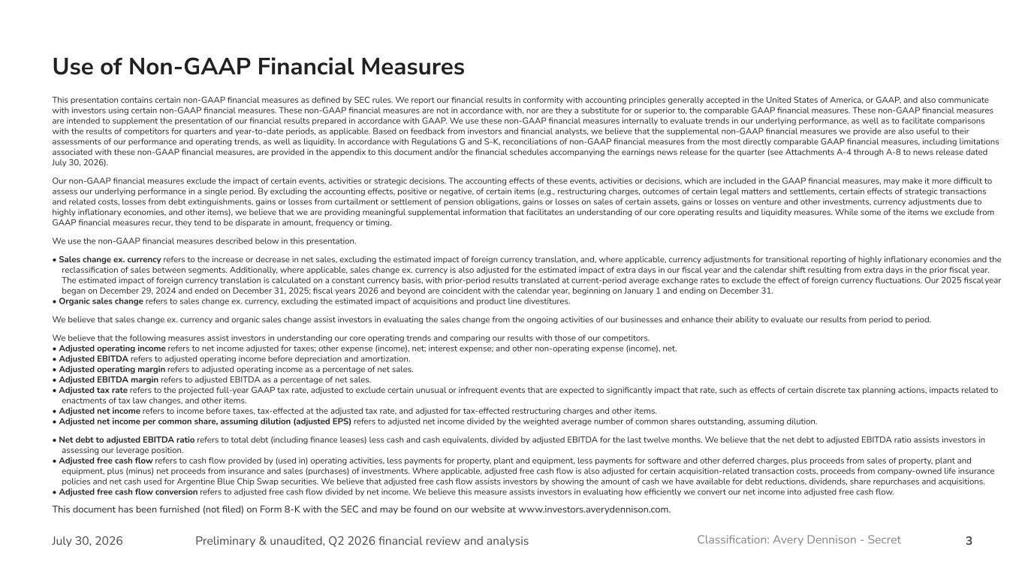
3July 30, 2026 Preliminary & unaudited, Q2 2026 financial review and analysis Classification: Avery Dennison - Secret Use of Non-GAAP Financial Measures This presentation contains certain non-GAAP financial measures as defined by SEC rules. We report our financial results in conformity with accounting principles generally accepted in the United States of America, or GAAP, and also communicate with investors using certain non-GAAP financial measures. These non-GAAP financial measures are not in accordance with, nor are they a substitute for or superior to, the comparable GAAP financial measures. These non-GAAP financial measures are intended to supplement the presentation of our financial results prepared in accordance with GAAP. We use these non-GAAP financial measures internally to evaluate trends in our underlying performance, as well as to facilitate comparisons with the results of competitors for quarters and year-to-date periods, as applicable. Based on feedback from investors and financial analysts, we believe that the supplemental non-GAAP financial measures we provide are also useful to their assessments of our performance and operating trends, as well as liquidity. In accordance with Regulations G and S-K, reconciliations of non-GAAP financial measures from the most directly comparable GAAP financial measures, including limitations associated with these non-GAAP financial measures, are provided in the appendix to this document and/or the financial schedules accompanying the earnings news release for the quarter (see Attachments A-4 through A-8 to news release dated July 30, 2026). Our non-GAAP financial measures exclude the impact of certain events, activities or strategic decisions. The accounting effects of these events, activities or decisions, which are included in the GAAP financial measures, may make it more difficult to assess our underlying performance in a single period. By excluding the accounting effects, positive or negative, of certain items (e.g., restructuring charges, outcomes of certain legal matters and settlements, certain effects of strategic transactions and related costs, losses from debt extinguishments, gains or losses from curtailment or settlement of pension obligations, gains or losses on sales of certain assets, gains or losses on venture and other investments, currency adjustments due to highly inflationary economies, and other items), we believe that we are providing meaningful supplemental information that facilitates an understanding of our core operating results and liquidity measures. While some of the items we exclude from GAAP financial measures recur, they tend to be disparate in amount, frequency or timing. We use the non-GAAP financial measures described below in this presentation. • Sales change ex. currency refers to the increase or decrease in net sales, excluding the estimated impact of foreign currency translation, and, where applicable, currency adjustments for transitional reporting of highly inflationary economies and the reclassification of sales between segments. Additionally, where applicable, sales change ex. currency is also adjusted for the estimated impact of extra days in our fiscal year and the calendar shift resulting from extra days in the prior fiscal year. The estimated impact of foreign currency translation is calculated on a constant currency basis, with prior-period results translated at current-period average exchange rates to exclude the effect of foreign currency fluctuations. Our 2025 fiscal year began on December 29, 2024 and ended on December 31, 2025; fiscal years 2026 and beyond are coincident with the calendar year, beginning on January 1 and ending on December 31. • Organic sales change refers to sales change ex. currency, excluding the estimated impact of acquisitions and product line divestitures. We believe that sales change ex. currency and organic sales change assist investors in evaluating the sales change from the ongoing activities of our businesses and enhance their ability to evaluate our results from period to period. We believe that the following measures assist investors in understanding our core operating trends and comparing our results with those of our competitors. • Adjusted operating income refers to net income adjusted for taxes; other expense (income), net; interest expense; and other non-operating expense (income), net. • Adjusted EBITDA refers to adjusted operating income before depreciation and amortization. • Adjusted operating margin refers to adjusted operating income as a percentage of net sales. • Adjusted EBITDA margin refers to adjusted EBITDA as a percentage of net sales. • Adjusted tax rate refers to the projected full-year GAAP tax rate, adjusted to exclude certain unusual or infrequent events that are expected to significantly impact that rate, such as effects of certain discrete tax planning actions, impacts related to enactments of tax law changes, and other items. • Adjusted net income refers to income before taxes, tax-effected at the adjusted tax rate, and adjusted for tax-effected restructuring charges and other items. • Adjusted net income per common share, assuming dilution (adjusted EPS) refers to adjusted net income divided by the weighted average number of common shares outstanding, assuming dilution. • Net debt to adjusted EBITDA ratio refers to total debt (including finance leases) less cash and cash equivalents, divided by adjusted EBITDA for the last twelve months. We believe that the net debt to adjusted EBITDA ratio assists investors in assessing our leverage position. • Adjusted free cash flow refers to cash flow provided by (used in) operating activities, less payments for property, plant and equipment, less payments for software and other deferred charges, plus proceeds from sales of property, plant and equipment, plus (minus) net proceeds from insurance and sales (purchases) of investments. Where applicable, adjusted free cash flow is also adjusted for certain acquisition-related transaction costs, proceeds from company-owned life insurance policies and net cash used for Argentine Blue Chip Swap securities. We believe that adjusted free cash flow assists investors by showing the amount of cash we have available for debt reductions, dividends, share repurchases and acquisitions. • Adjusted free cash flow conversion refers to adjusted free cash flow divided by net income. We believe this measure assists investors in evaluating how efficiently we convert our net income into adjusted free cash flow. This document has been furnished (not filed) on Form 8-K with the SEC and may be found on our website at www.investors.averydennison.com.

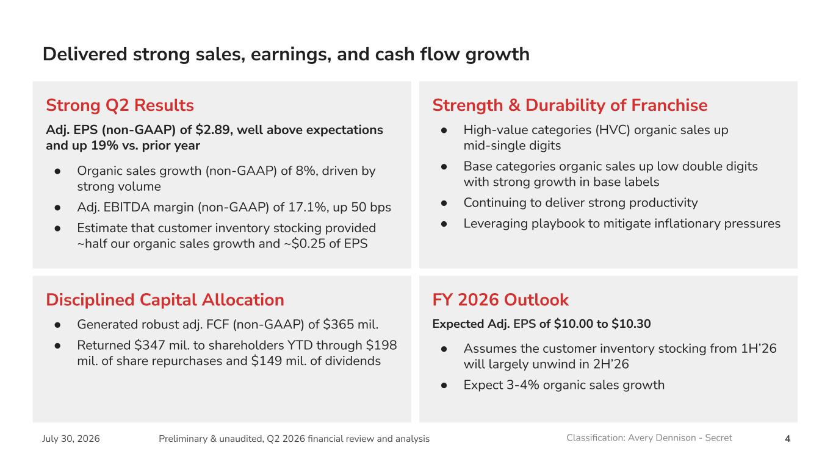
4July 30, 2026 Preliminary & unaudited, Q2 2026 financial review and analysis Classification: Avery Dennison - Secret Delivered strong sales, earnings, and cash flow growth Strong Q2 Results Adj. EPS (non-GAAP) of $2.89, well above expectations and up 19% vs. prior year ● Organic sales growth (non-GAAP) of 8%, driven by strong volume ● Adj. EBITDA margin (non-GAAP) of 17.1%, up 50 bps ● Estimate that customer inventory stocking provided ~half our organic sales growth and ~$0.25 of EPS Strength & Durability of Franchise ● High-value categories (HVC) organic sales up mid-single digits ● Base categories organic sales up low double digits with strong growth in base labels ● Continuing to deliver strong productivity ● Leveraging playbook to mitigate inflationary pressures FY 2026 Outlook Expected Adj. EPS of $10.00 to $10.30 ● Assumes the customer inventory stocking from 1H’26 will largely unwind in 2H’26 ● Expect 3-4% organic sales growth Disciplined Capital Allocation ● Generated robust adj. FCF (non-GAAP) of $365 mil. ● Returned $347 mil. to shareholders YTD through $198 mil. of share repurchases and $149 mil. of dividends

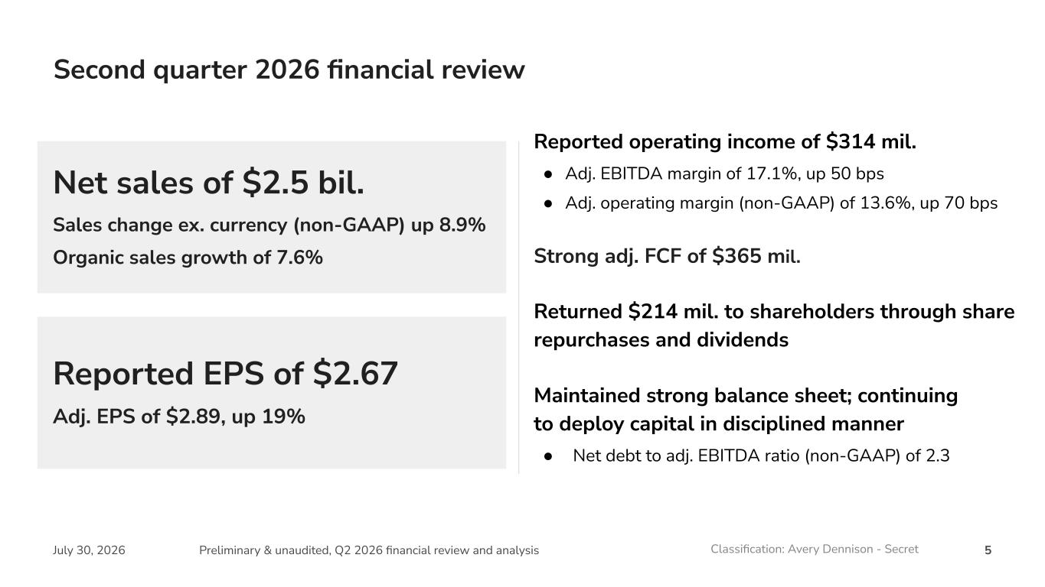
5July 30, 2026 Preliminary & unaudited, Q2 2026 financial review and analysis Classification: Avery Dennison - Secret Reported EPS of $2.67 Adj. EPS of $2.89, up 19% Net sales of $2.5 bil. Sales change ex. currency (non-GAAP) up 8.9% Organic sales growth of 7.6% Second quarter 2026 financial review Reported operating income of $314 mil. ● Adj. EBITDA margin of 17.1%, up 50 bps ● Adj. operating margin (non-GAAP) of 13.6%, up 70 bps Strong adj. FCF of $365 mil. Returned $214 mil. to shareholders through share repurchases and dividends Maintained strong balance sheet; continuing to deploy capital in disciplined manner ● Net debt to adj. EBITDA ratio (non-GAAP) of 2.3

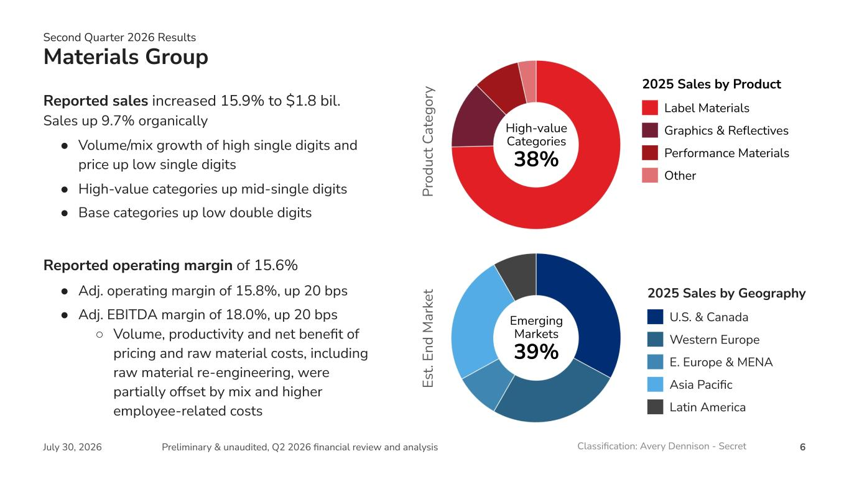
6July 30, 2026 Preliminary & unaudited, Q2 2026 financial review and analysis Classification: Avery Dennison - Secret Materials Group Reported sales increased 15.9% to $1.8 bil. Sales up 9.7% organically ● Volume/mix growth of high single digits and price up low single digits ● High-value categories up mid-single digits ● Base categories up low double digits Reported operating margin of 15.6% ● Adj. operating margin of 15.8%, up 20 bps ● Adj. EBITDA margin of 18.0%, up 20 bps ○ Volume, productivity and net benefit of pricing and raw material costs, including raw material re-engineering, were partially offset by mix and higher employee-related costs Emerging Markets 39% Es t. En d M ar ke t Pr od uc t C at eg or y Second Quarter 2026 Results 2025 Sales by Product Label Materials Graphics & Reflectives Performance Materials Other High-value Categories 38% 2025 Sales by Geography U.S. & Canada Western Europe E. Europe & MENA Asia Pacific Latin America

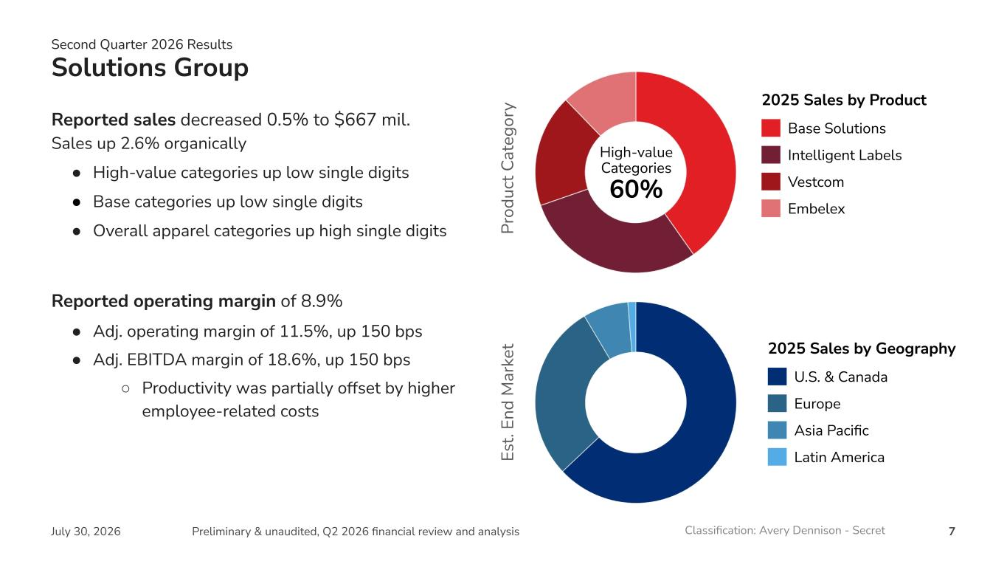
7July 30, 2026 Preliminary & unaudited, Q2 2026 financial review and analysis Classification: Avery Dennison - Secret Solutions Group Reported sales decreased 0.5% to $667 mil. Sales up 2.6% organically ● High-value categories up low single digits ● Base categories up low single digits ● Overall apparel categories up high single digits Reported operating margin of 8.9% ● Adj. operating margin of 11.5%, up 150 bps ● Adj. EBITDA margin of 18.6%, up 150 bps ○ Productivity was partially offset by higher employee-related costs 2025 Sales by Product Base Solutions Intelligent Labels Vestcom Embelex 2025 Sales by Geography U.S. & Canada Europe Asia Pacific Latin America High-value Categories 60% Second Quarter 2026 Results Es t. En d M ar ke t Pr od uc t C at eg or y

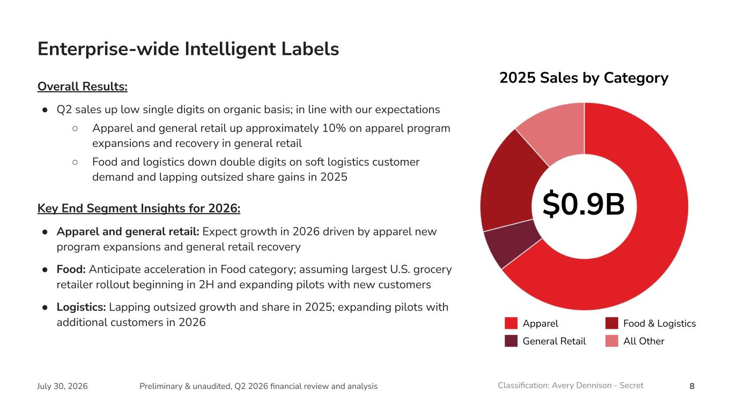
8July 30, 2026 Preliminary & unaudited, Q2 2026 financial review and analysis Classification: Avery Dennison - Secret Enterprise-wide Intelligent Labels Apparel General Retail $0.9B 2025 Sales by Category Food & Logistics All Other Overall Results: ● Q2 sales up low single digits on organic basis; in line with our expectations ○ Apparel and general retail up approximately 10% on apparel program expansions and recovery in general retail ○ Food and logistics down double digits on soft logistics customer demand and lapping outsized share gains in 2025 Key End Segment Insights for 2026: ● Apparel and general retail: Expect growth in 2026 driven by apparel new program expansions and general retail recovery ● Food: Anticipate acceleration in Food category; assuming largest U.S. grocery retailer rollout beginning in 2H and expanding pilots with new customers ● Logistics: Lapping outsized growth and share in 2025; expanding pilots with additional customers in 2026

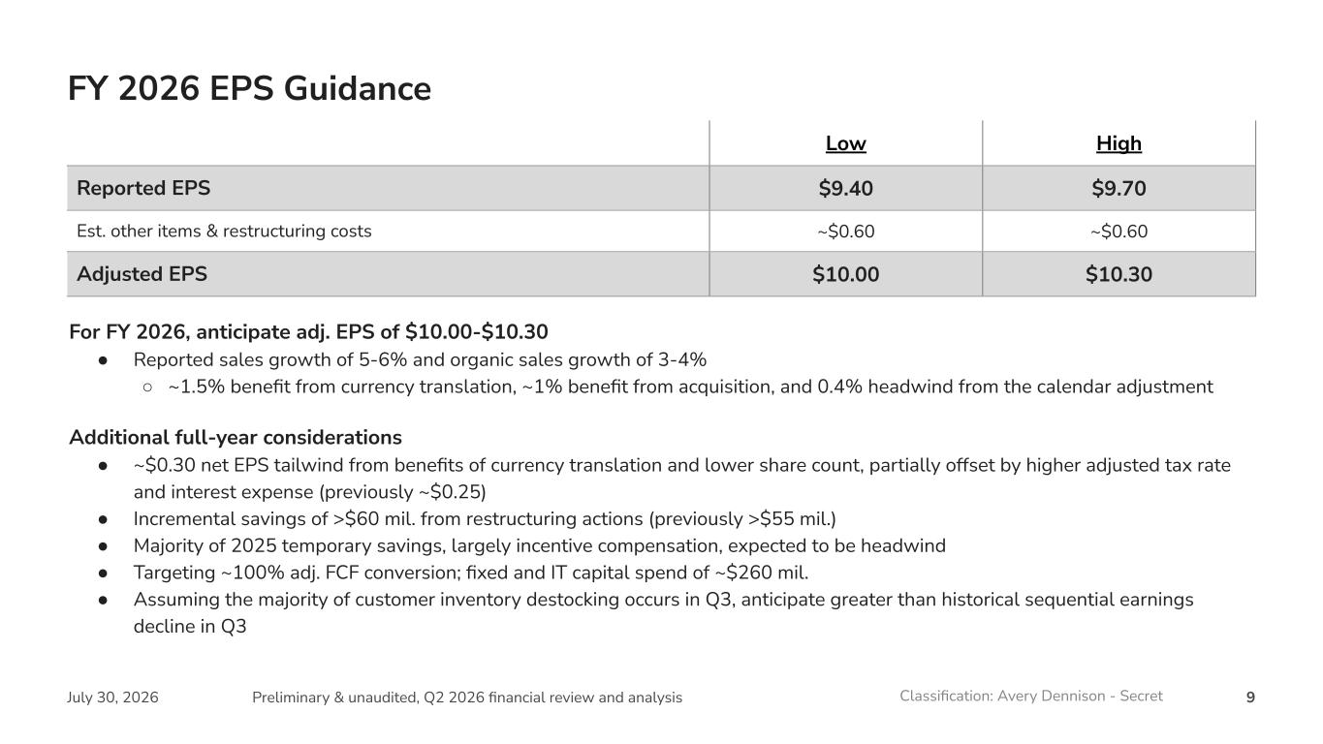
9July 30, 2026 Preliminary & unaudited, Q2 2026 financial review and analysis Classification: Avery Dennison - Secret Low High Reported EPS $9.40 $9.70 Est. other items & restructuring costs ~$0.60 ~$0.60 Adjusted EPS $10.00 $10.30 FY 2026 EPS Guidance For FY 2026, anticipate adj. EPS of $10.00-$10.30 ● Reported sales growth of 5-6% and organic sales growth of 3-4% ○ ~1.5% benefit from currency translation, ~1% benefit from acquisition, and 0.4% headwind from the calendar adjustment Additional full-year considerations ● ~$0.30 net EPS tailwind from benefits of currency translation and lower share count, partially offset by higher adjusted tax rate and interest expense (previously ~$0.25) ● Incremental savings of >$60 mil. from restructuring actions (previously >$55 mil.) ● Majority of 2025 temporary savings, largely incentive compensation, expected to be headwind ● Targeting ~100% adj. FCF conversion; fixed and IT capital spend of ~$260 mil. ● Assuming the majority of customer inventory destocking occurs in Q3, anticipate greater than historical sequential earnings decline in Q3

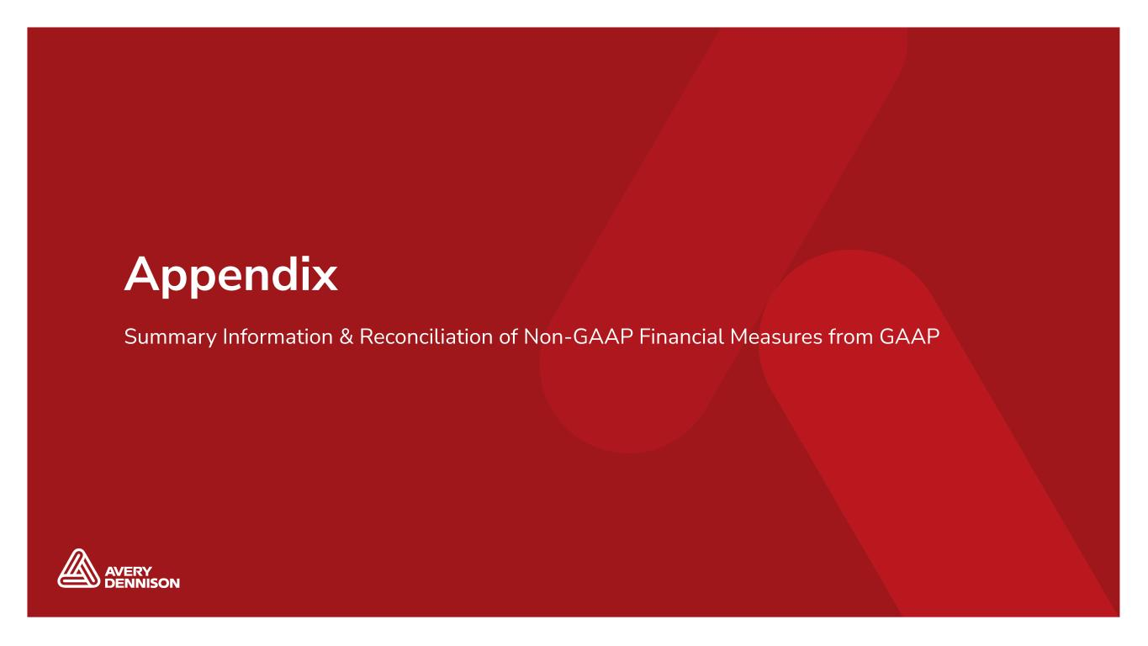
Classification: Avery Dennison - Secret 10September 18, 2024 Avery Dennison 2024 Investor Day Appendix Summary Information & Reconciliation of Non-GAAP Financial Measures from GAAP

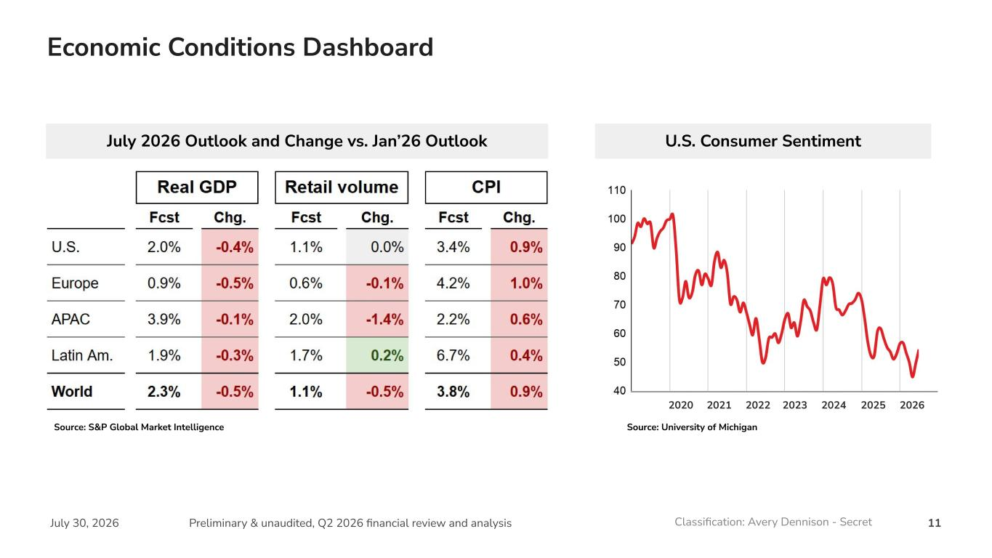
11July 30, 2026 Preliminary & unaudited, Q2 2026 financial review and analysis Classification: Avery Dennison - Secret Source: S&P Global Market Intelligence U.S. Consumer Sentiment Economic Conditions Dashboard 2020 2021 2022 2023 2024 2025 2026 July 2026 Outlook and Change vs. Jan’26 Outlook Source: University of Michigan

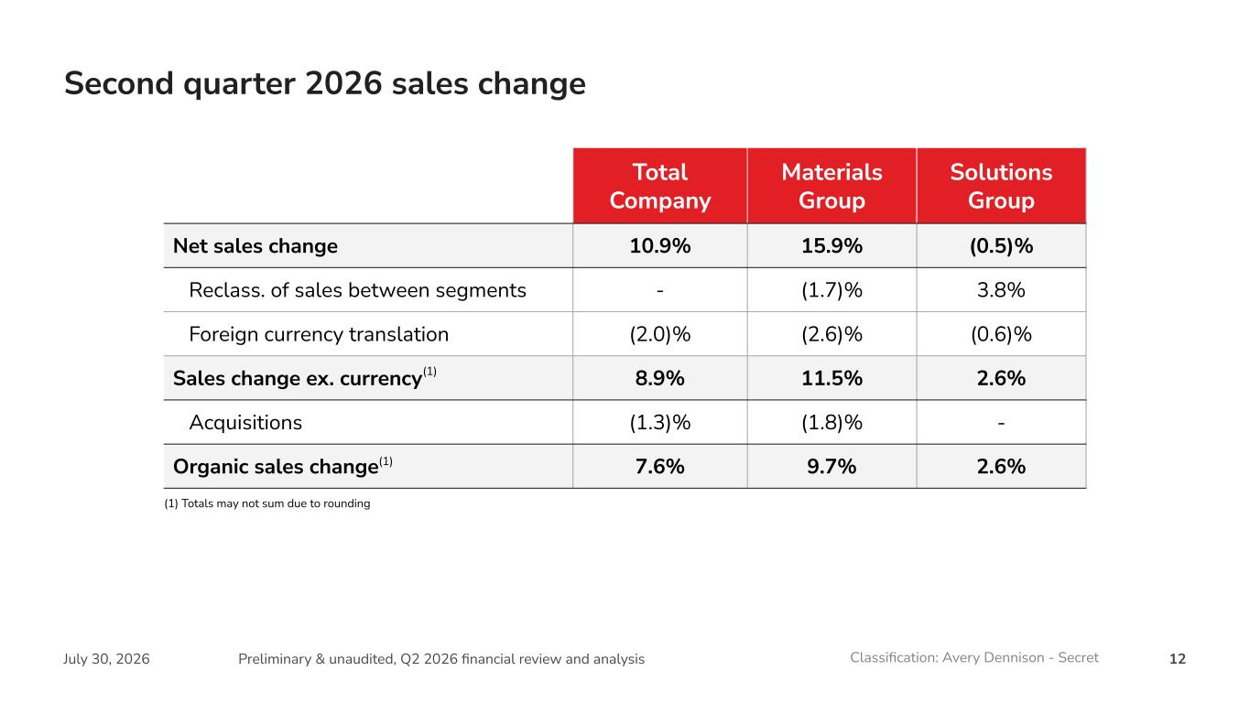
12July 30, 2026 Preliminary & unaudited, Q2 2026 financial review and analysis Classification: Avery Dennison - Secret Second quarter 2026 sales change Total Company Materials Group Solutions Group Net sales change 10.9% 15.9% (0.5)% Reclass. of sales between segments - (1.7)% 3.8% Foreign currency translation (2.0)% (2.6)% (0.6)% Sales change ex. currency 8.9% 11.5% 2.6% Acquisitions (1.3)% (1.8)% - Organic sales change 7.6% 9.7% 2.6% (1) Totals may not sum due to rounding (1) (1)

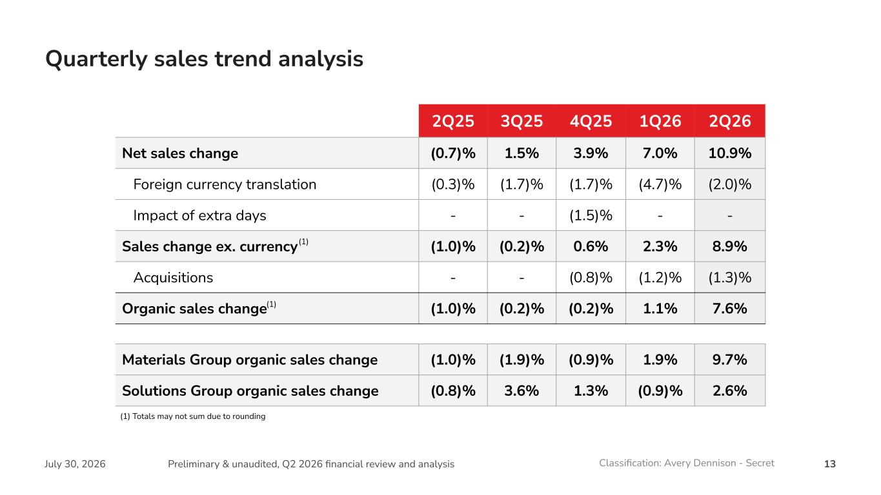
13July 30, 2026 Preliminary & unaudited, Q2 2026 financial review and analysis Classification: Avery Dennison - Secret Quarterly sales trend analysis 2Q25 3Q25 4Q25 1Q26 2Q26 Net sales change (0.7)% 1.5% 3.9% 7.0% 10.9% Foreign currency translation (0.3)% (1.7)% (1.7)% (4.7)% (2.0)% Impact of extra days - - (1.5)% - - Sales change ex. currency (1.0)% (0.2)% 0.6% 2.3% 8.9% Acquisitions - - (0.8)% (1.2)% (1.3)% Organic sales change (1.0)% (0.2)% (0.2)% 1.1% 7.6% Materials Group organic sales change (1.0)% (1.9)% (0.9)% 1.9% 9.7% Solutions Group organic sales change (0.8)% 3.6% 1.3% (0.9)% 2.6% (1) Totals may not sum due to rounding (1) (1)

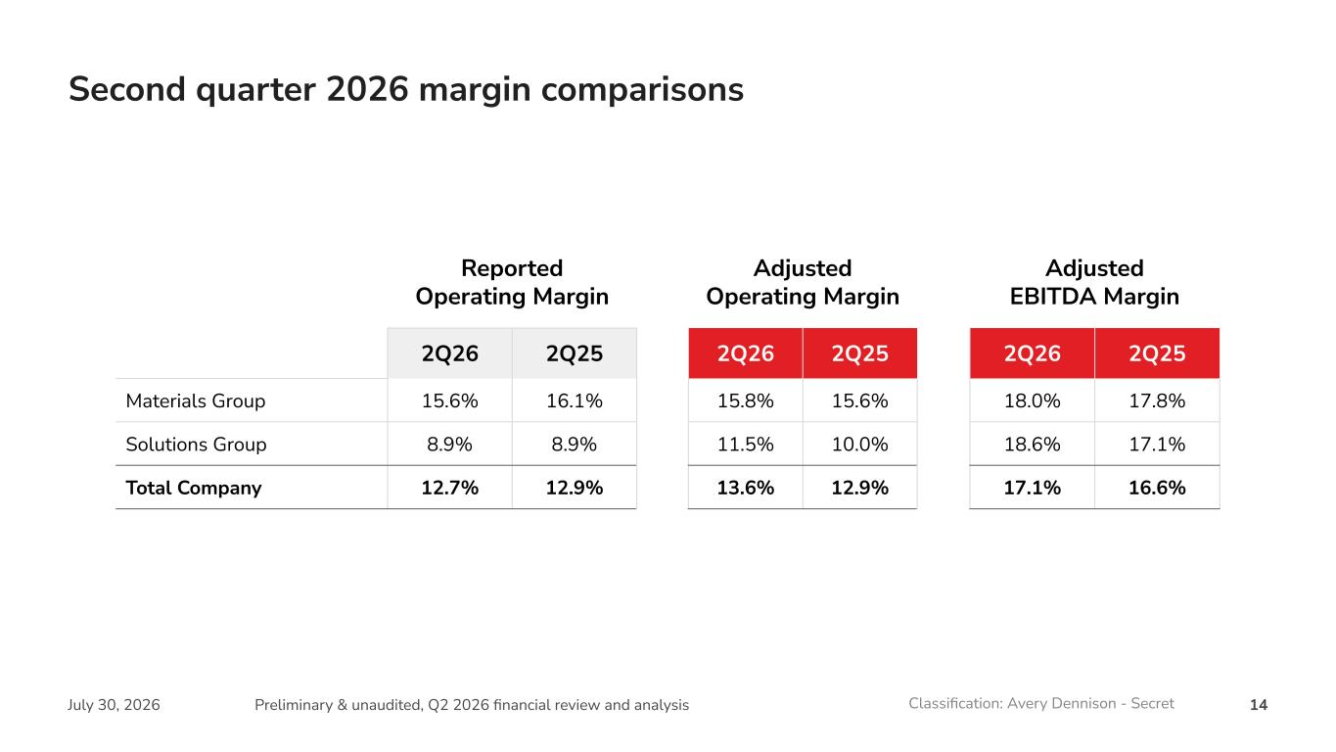
14July 30, 2026 Preliminary & unaudited, Q2 2026 financial review and analysis Classification: Avery Dennison - Secret Second quarter 2026 margin comparisons Reported Operating Margin Adjusted Operating Margin Adjusted EBITDA Margin 2Q26 2Q25 2Q26 2Q25 2Q26 2Q25 Materials Group 15.6% 16.1% 15.8% 15.6% 18.0% 17.8% Solutions Group 8.9% 8.9% 11.5% 10.0% 18.6% 17.1% Total Company 12.7% 12.9% 13.6% 12.9% 17.1% 16.6%

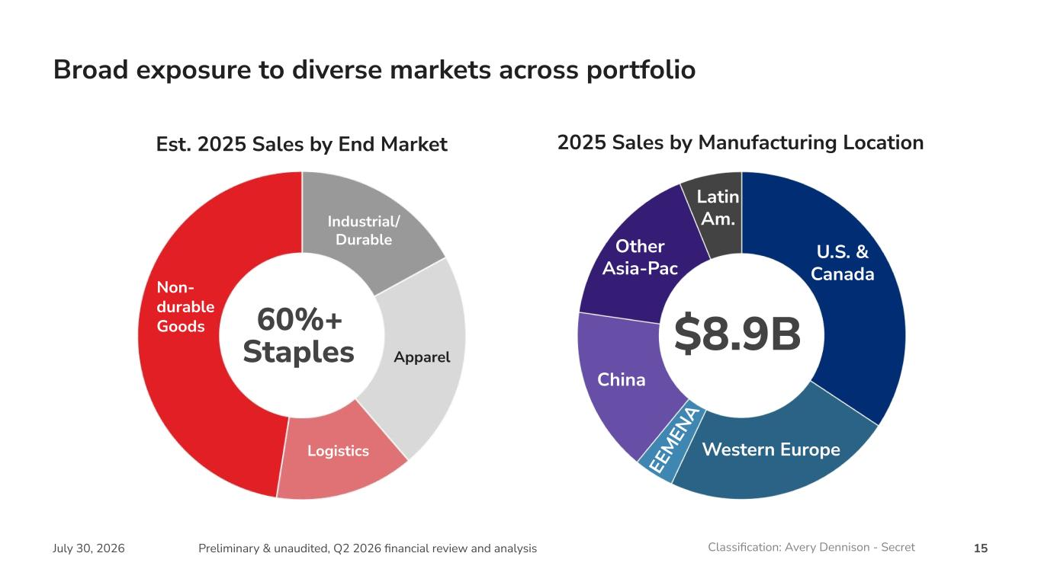
15July 30, 2026 Preliminary & unaudited, Q2 2026 financial review and analysis Classification: Avery Dennison - Secret Est. 2025 Sales by End Market Industrial/ Durable Apparel Broad exposure to diverse markets across portfolio 60%+ Staples Non- durable Goods Logistics $8.9B 2025 Sales by Manufacturing Location U.S. & Canada Western Europe China Other Asia-Pac Latin Am. EE M EN A


16July 30, 2026 Preliminary & unaudited, Q2 2026 financial review and analysis Classification: Avery Dennison - Secret © 2026 Avery Dennison Corporation. All rights reserved. The “Making Possible” tagline, Avery Dennison and all other Avery Dennison brands, product names and codes are trademarks of Avery Dennison Corporation. All other brands or product names are trademarks of their respective owners. Fortune 500® is a trademark of Time, Inc. Branding and other information on any samples depicted are fictitious. Any resemblance to actual names is purely coincidental. averydennison.com #MakingPossible

